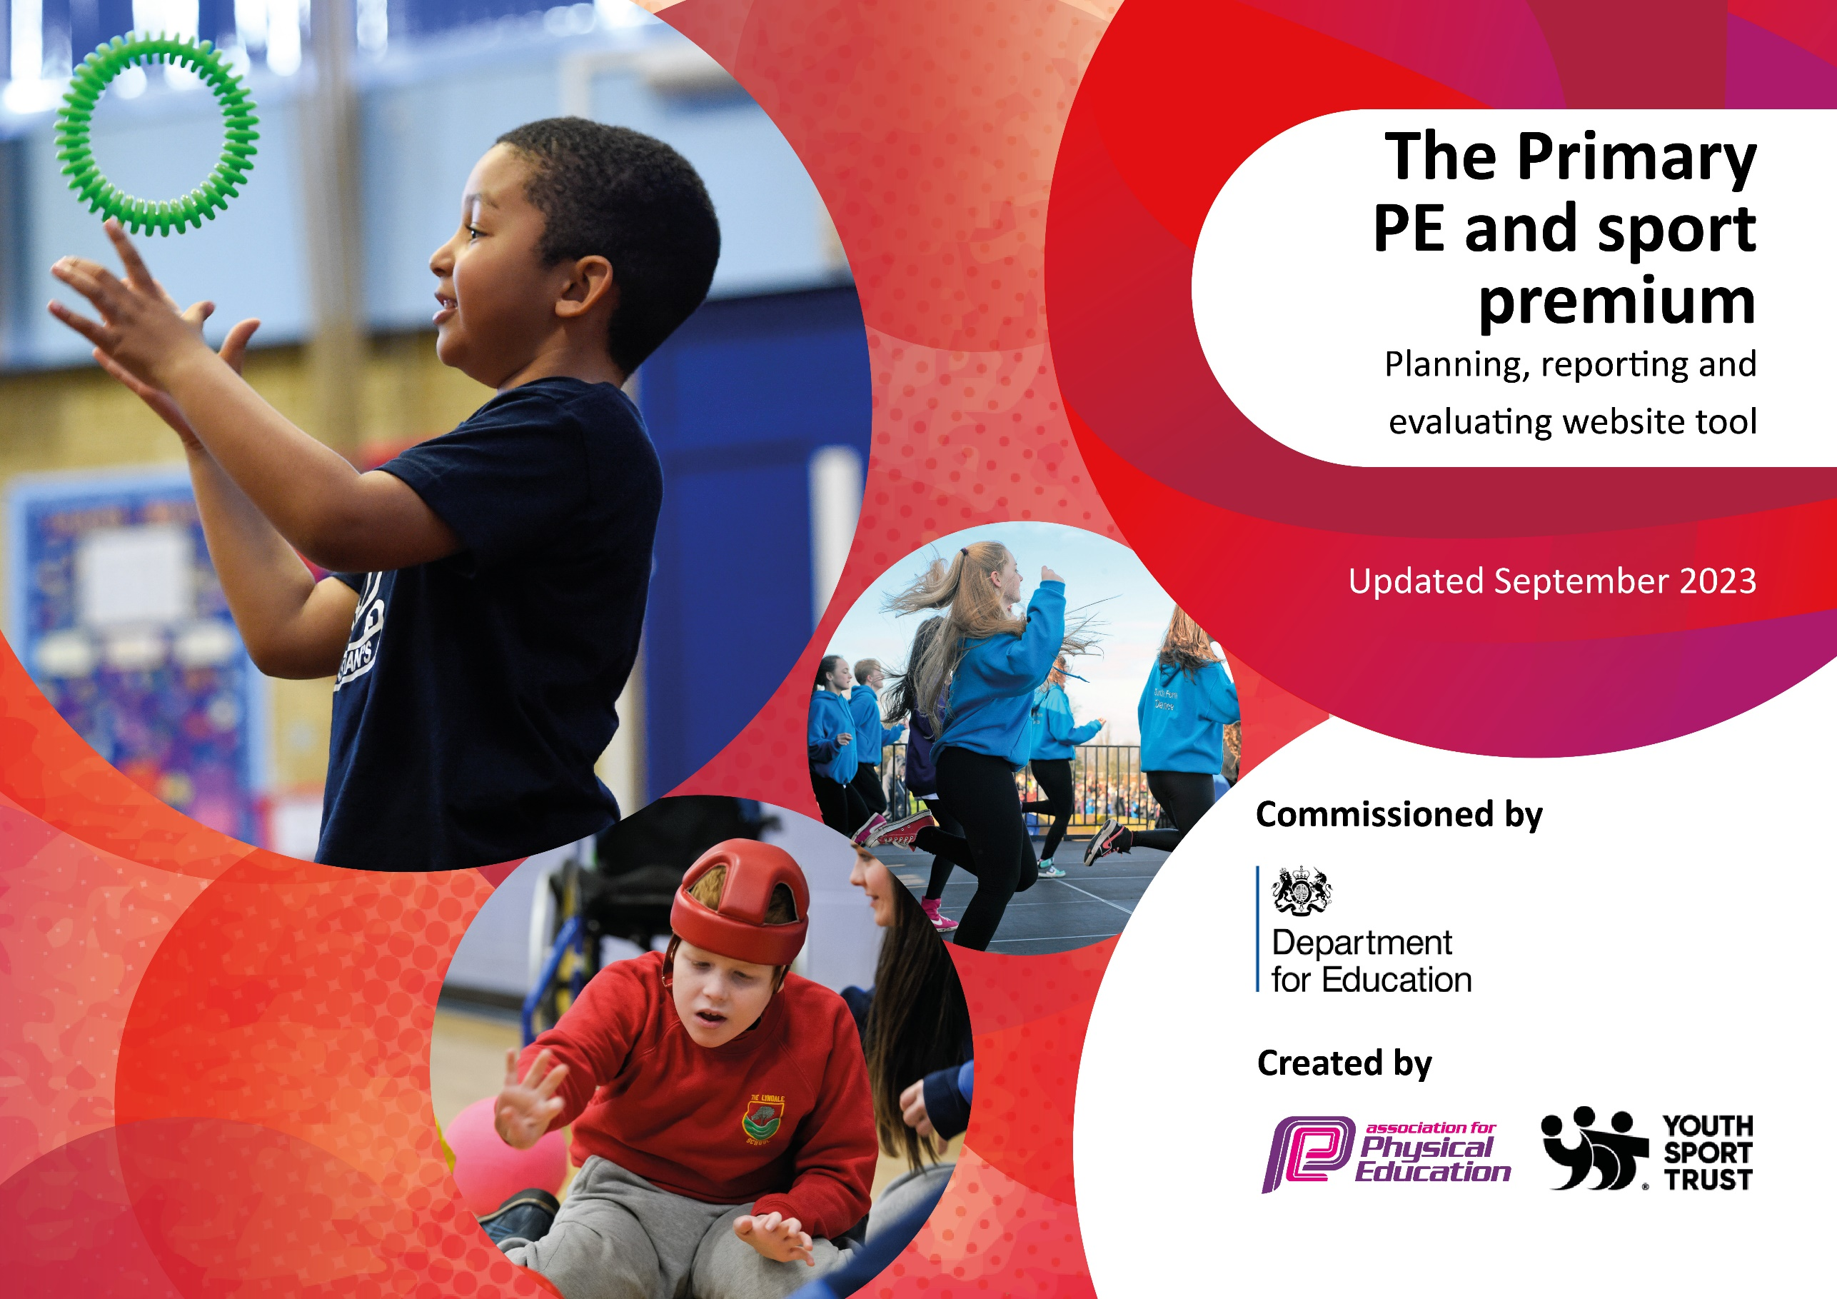

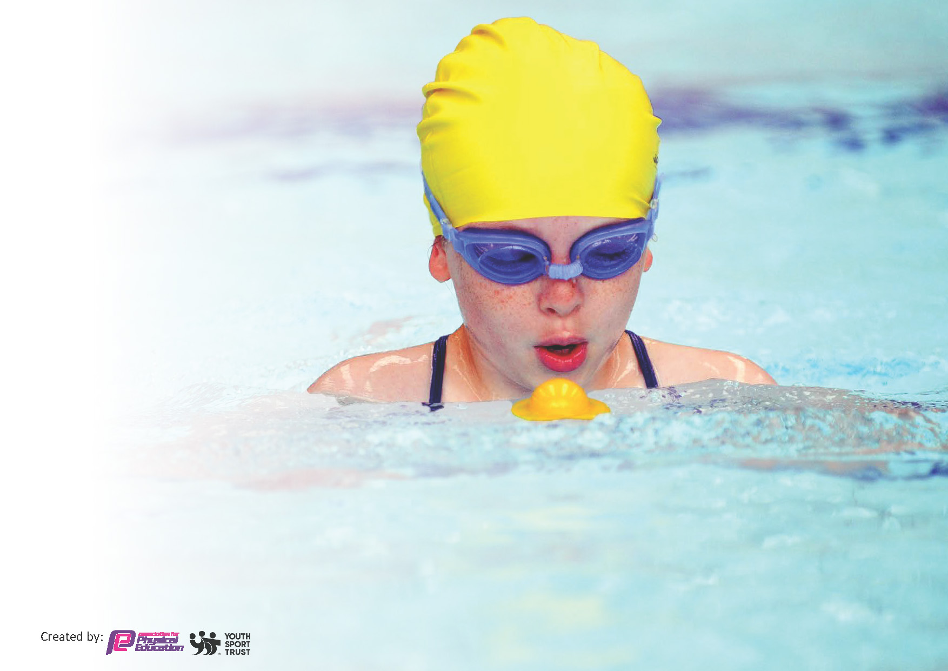
This template can be used for multiple purposes:
by:
- It enables schools to effectively plan their use of the Primary PE and sport premium
- It helps schools to meet the requirements (as set out in guidance) to publish information on their Primary PE and sport premium
- It will be an effective document to support Ofsted inspections enabling schools to evidence progress in Physical Education (PE) and evidence swimming attainment, which forms part of the PE National Curriculum. We would recommend schools consider
the Intent, Implementation and Impact of any spend, as examined within the Education Inspection Framework.

It is important that your grant is used effectively and based on school need.

Schools must use the funding to make additional and sustainable
improvements to the quality of the PE, School Sport and Physical Activity (PESSPA)
they offer. This means that you should use the Primary PE and sport premium to:

- Build capacity and capability within the school to ensure that improvements made now will benefit pupils joining the school in future years
- Develop or add to the PESSPA activities that your school already offers.

The Primary PE and sport premium should not be used to fund capital spend projects; the school’s core budget should fund these. Further detail on capital expenditure can be found in the updated Primary PE and sport premium guidance.

The Primary PE and sport premium guidance, outlines 5 key priorities that funding should be used towards. It is not

necessary that spending has to meet all the key priorities, you should select the priorities that you aim to use any funding towards.

Although completing this template is not a requirement for schools, schools are required to publish details of how they spend this funding. Schools must also outline what the impact this funding has had on pupils’ PE and sport participation and attainment and how any spending will be sustainable in the future. All funding must be spent by 31st July 2024.

The Department for Education has worked closely with the Association for Physical Education (afPE) and the Youth Sport Trust (YST) to develop this template and encourages schools to use it. This template is an effective way of meeting the reporting requirements of the Primary PE and sport premium.
Review of last year’s spend and key achievements (2022/2023)

We recommend you start by reflecting on the impact of current provision and reviewing your previous spend.

Activity/Action | Impact | Comments
Gold standard achieved in Sportsmark in 2022-2023.  Existing PE lead worked alongside colleague for the year to cascade information and to support in preparation for new role.  Staff CPD in delivery of PE lessons. | More staff confident and trained as subject leads.  Increased participation in after school sports clubs.  Increased pupil engagement in PE lessons.

Key priorities and Planning
This planning template will allow schools to accurately plan their spending.

Action – what are you planning to do | Who does this action impact? | Key indicator to meet | Impacts and how sustainability will be achieved? | Cost linked to the action
Develop member of staff new to role as PE subject lead.  To introduce pupils to a wider range of outdoor and adventurous activities.  To provide forest school activities for EYs and KS1 pupils.  To adapt activities and/or provide additional support for SEND pupils in all PE lessons.  Attend planned for competitive events/festivals. PE lead to attend cluster PE meetings.  Staff CPD with coaching staff to adapt and increase participation for pupils with SEND.  Add to existing PE resources  Provision of after school clubs- external providers  Celebration of success in sport- in and out of school. Friday achievement assemblies | All staff  All pupils  All pupils  All pupils  Staff and pupils  Pupils  Pupils  All pupils | Key Indicator 1: Increased confidence, knowledge, and skills of all staff in teaching PE and sport.  Key indicator 4: Broader experience of a range of sports and activities offered to all pupils.  Key indicator 2 -The engagement of all pupils in regular physical activity  Key indicator 5: Increased participation in competitive sport.  Key indicator 2 -The engagement of all pupils in regular physical activity –  Key indicator 2 -The engagement of all pupils in regular physical activity –  Key indicator 2 -The engagement of all pupils in regular physical activity  Key indicator 3- the profile of PE and sport raised across whole school. | More pupils meeting their daily physical activity goal, more pupils encouraged to take part in PE and Sport Activities. Pupils more resilient and enthusiastic about participation in PE and extra curricular activities.  Staff able to deliver a range of sports following input from specialist coaching staff.  Off site forest School and Outdoor and adventurous activities planned in at the start of each academic year.  Staff able to use skills learnt to continue to adapt activities.  Pupils have access to well maintained PE and play equipment.  More pupils meeting daily physical activity goal and improved participation. Improvement in skill levels.  Pupils motivated and inspired by others. | £1000  £1500  £500  £2000 transport costs  £2800  £1000  £2000  No cost

Key achievements 2023-2024
This template will be completed at the end of the academic year and will showcase the key achievements schools have made with their Primary PE and sport premium spending.

Activity/Action | Impact | Comments
New subject lead for PE has accessed training through National College and has worked with sports partnership lead to draw up PE timetables and activities.  Staff have worked alongside coaches or school staff to adapt activities for SEND pupils.  School has worked with other cluster schools to develop a sports competition calendar for next academic year that builds on what was feasible this year.  Staff able to choreograph dance for county wide dance festival.  Increase in variety and amount of outdoor and adventurous that school able to offer.  Outdoor play equipment added to. | Staff member confident in role and able to articulate how PE is delivered and assessed from EYs to Yr 6. Staff member applied for Sportsmark- awaiting the outcome for this academic year.  Staff more confident at adapting/modifying activities and increased pupil participation.  The full impact will be seen next academic year when we should be able to return to the levels of competition involvement that has previously existed.  All pupils in the class participated. Staff able to lead with confidence and able to adapt routine effectively for SEND pupils.  Pupil participation, enjoyment and engagement. Impact on pupil well-being and resilience.  Pupils able to access good quality play equipment at break times and increased engagement for more reluctant pupils.

Swimming Data
Meeting National Curriculum requirements for swimming and water safety.
Priority should always be given to ensuring that pupils can perform safe self-rescue even if they do not fully meet the first two requirements of the National Curriculum programme of study

Question | Stats: | Further context  Relative to local challenges
What percentage of your current Year 6 cohort can swim competently, confidently and proficiently over a distance of at least 25 metres? | 100%
What percentage of your current Year 6 cohort can use a range of strokes effectively [for example, front crawl, backstroke, and breaststroke]? | 100%

What percentage of your current Year 6 cohort are able to perform safe self-rescue in different water-based situations? | 100%
If your schools swimming data is below national expectation, you can choose to use the Primary PE and sport premium to provide additional top-up sessions for those pupils that did not meet National Curriculum  requirements after the completion of core lessons. Have you done this? | N/A
Have you provided CPD to improve the knowledge and confidence of staff to be able to teach swimming and water safety? | No

Signed off by:

Head Teacher: | Amanda Pitcher
Subject Leader or the individual responsible for the Primary PE and sport premium: | Miss C Anderson Class Teacher
Governor: | Mark Dawson
Date: | 10/7/24

